Trần văn mạnh 20221188
ảnh kết quả
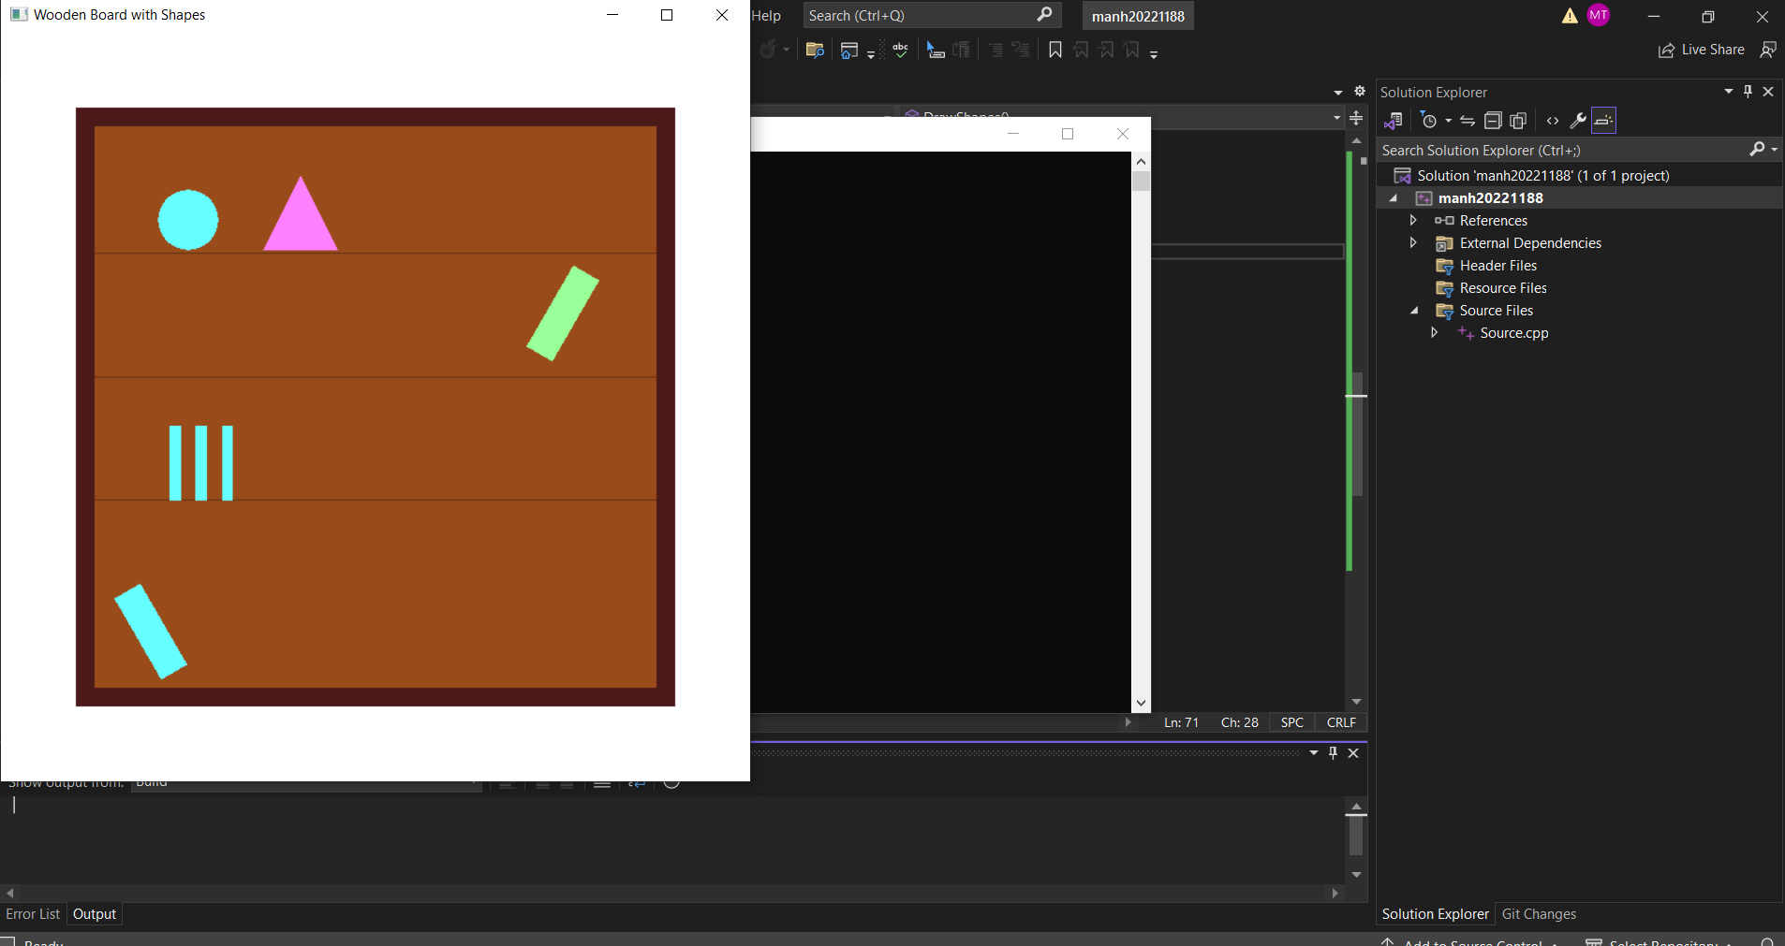

CODE:

#include "glut.h"
#include "cmath"

#define PI 3.14159265

void drawCircle(float cx, float cy, float r, int num_segments) {
glBegin(GL_POLYGON);
for (int i = 0; i < num_segments; i++) {
float theta = 2.0f * PI * i / num_segments;
float x = r * cos(theta);
float y = r * sin(theta);
glVertex2f(x + cx, y + cy);
}
glEnd();
}

void drawRotatedRect(float cx, float cy, float width, float height, float angleDeg, float r, float g, float b) {
glPushMatrix();
glTranslatef(cx, cy, 0);
glRotatef(angleDeg, 0, 0, 1);
glColor3f(r, g, b);
glBegin(GL_POLYGON);
glVertex2f(-width / 2, -height / 2);
glVertex2f(width / 2, -height / 2);
glVertex2f(width / 2, height / 2);
glVertex2f(-width / 2, height / 2);
glEnd();
glPopMatrix();
}

void DrawBoard() {

glColor3f(0.3, 0.1, 0.1);
glBegin(GL_POLYGON);
glVertex2f(-0.8f, -0.8f);
glVertex2f(0.8f, -0.8f);
glVertex2f(0.8f, 0.8f);
glVertex2f(-0.8f, 0.8f);
glEnd();

glColor3f(0.6, 0.3, 0.1);
glBegin(GL_POLYGON);
glVertex2f(-0.75f, -0.75f);
glVertex2f(0.75f, -0.75f);
glVertex2f(0.75f, 0.75f);
glVertex2f(-0.75f, 0.75f);
glEnd();

glColor3f(0.4, 0.2, 0.1);
float y = -0.25f;
for (int i = 0; i < 3; i++) {
glBegin(GL_LINES);
glVertex2f(-0.75f, y);
glVertex2f(0.75f, y);
glEnd();
y += 0.33f;
}
}

void DrawShapes() {

glColor3f(0.4f, 1.0f, 1.0f);
drawCircle(-0.5f, 0.5f, 0.08f, 100);

glColor3f(1.0, 0.5, 1.0);
glBegin(GL_TRIANGLES);
glVertex2f(-0.3, 0.42);
glVertex2f(-0.2, 0.62);
glVertex2f(-0.1, 0.42);
glEnd();

float x_start = -0.55;
for (int i = 0; i < 3; i++) {
glColor3f(0.4, 1.0, 1.0);
glBegin(GL_POLYGON);
glVertex2f(x_start + i * 0.07, -0.25);
glVertex2f(x_start + i * 0.07 + 0.03, -0.25);
glVertex2f(x_start + i * 0.07 + 0.03, -0.05);
glVertex2f(x_start + i * 0.07, -0.05);
glEnd();
}

drawRotatedRect(0.5f, 0.25f, 0.08f, 0.25f, -30.0f, 0.6f, 1.0f, 0.6f);

drawRotatedRect(-0.6f, -0.60f, 0.08f, 0.25f, 30.0f, 0.4f, 1.0f, 1.0f);
}

void Display() {
glClear(GL_COLOR_BUFFER_BIT);
DrawBoard();
DrawShapes();
glFlush();
}

void Init() {
glClearColor(1, 1, 1, 1);
glMatrixMode(GL_PROJECTION);
glLoadIdentity();
gluOrtho2D(-1, 1, -1, 1);
}

int main(int argc, char** argv) {
glutInit(&argc, argv);
glutInitWindowSize(640, 640);
glutInitDisplayMode(GLUT_SINGLE | GLUT_RGB);
glutCreateWindow("Wooden Board with Shapes");
Init();
glutDisplayFunc(Display);
glutMainLoop();
return 0;
}

